Rehabilitation Emergency Protocols:

- Emergency Procedure:
  - Community Rehab
    - Changes in light of COVID – including PPE requirements
  - Virtual Rehab
  - Face to face rehab on site
- When to Contact GP/111/999
- Emergency Instructions
- Community Venue Details
- SBAR

UPDATE 17/9/20: DW Resus team. Our areas are amber risk (in a hospital or community setting) as patients undergo a COVID questionnaire and temperature check but no COVID swab. This means that level 3 PPE IS required for any ventilatory AGP eg bag valve mask but now CHEST COMPRESSION CAN BE STARTED IMMEDIATELY whilst other team members don PPE. Resus council infographics not updated as yet to reflect these changes.

Emergency Procedure: Community Rehabilitation

Suspicion of Cardiac Arrest/Collapse





Call for HELP!
Assess patient
ABCDE
Signs of Life
NO
Call 999
YES
REASSESS ABCDE
ASSESS & TREAT WHERE POSSIBLE
EARLY DE-FIB
(APPLY PADS AND FOLLOW INSTRUCTIONS)
CPR 30:2
WITH O2 & AIRWAY ADJUNCTS

CALL 999
If continues to deteriorate
(Handover to emergency services)

Alteration to resuscitation in line with guidance due to COVID:

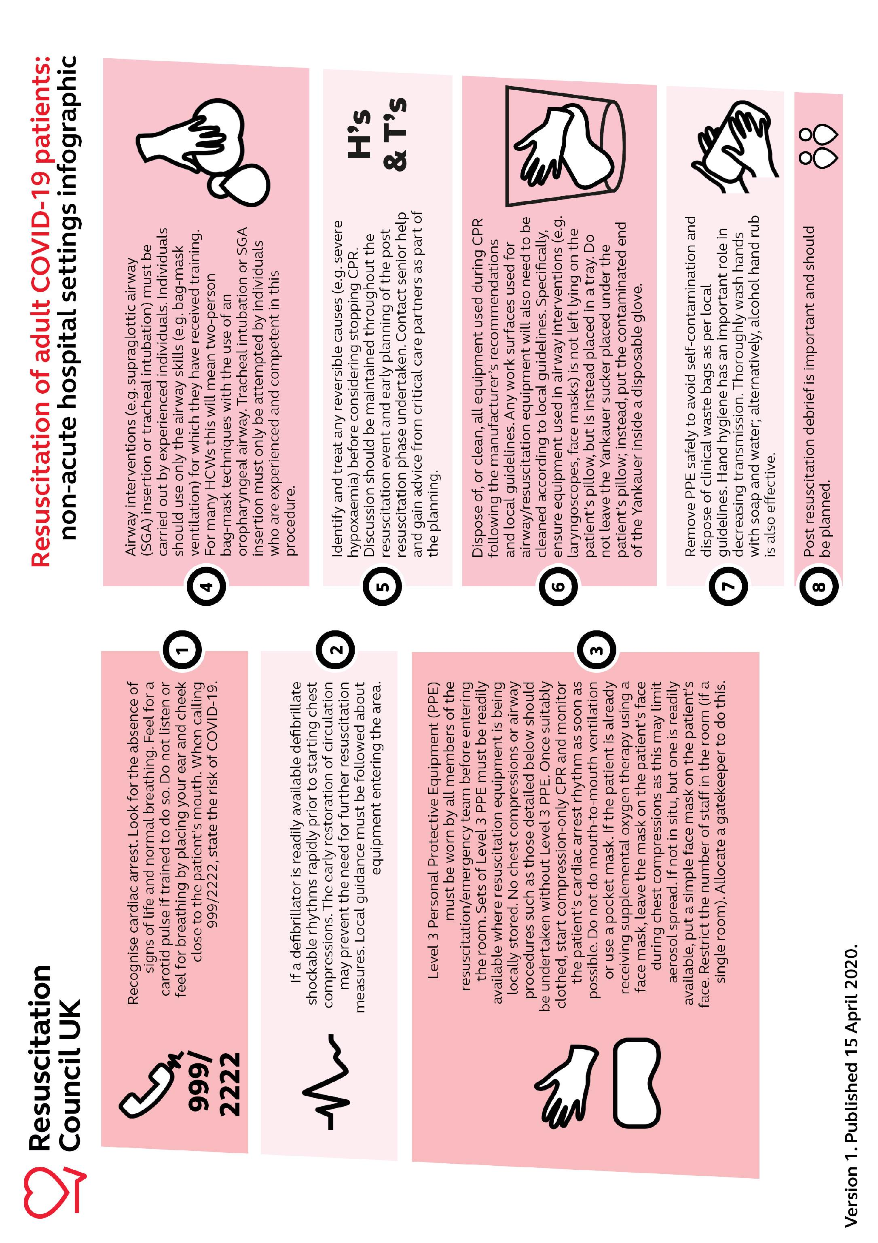

To enable this it is essential to have appropriate PPE in the emergency kit for CPR: (per staff member) FFP 3 mask, gloves, visor, long sleeved fluid repellant/resistant gown with apron underneath

Resuscitation guidance for remote sessions:

Patients reports feeling unwell/concern over patient

Does it appear to be a medical emergency?

CLASS ENDS AND OTHER PATIENTS MUST LOG OFF IMMEDIATELY
ENSURE UNWELL PATIENTS COMPANION IS PRESENT TO AID ASSESSMENT – GUIDE COMPANION WITH ABCDE ASSESSMENT

Signs of Life

NO
Companion calls 999
YES

Reassess ABCDE with companion
Guide Ax & Rx as possible
Companion follows advice of call handler. Staff stays online to advise if possible and hand over to emergency services if required

Follow action plan for symptoms
- GTN protocol for chest pain
- reliever inhailor/breathing control for dyspnea

CALL 999 if deteriorates
Once symptoms settle agree plan eg follow up call following day
Reiterate contacting 111 / 999 if symptoms worsen

Resuscitation guidance for on site sessions:
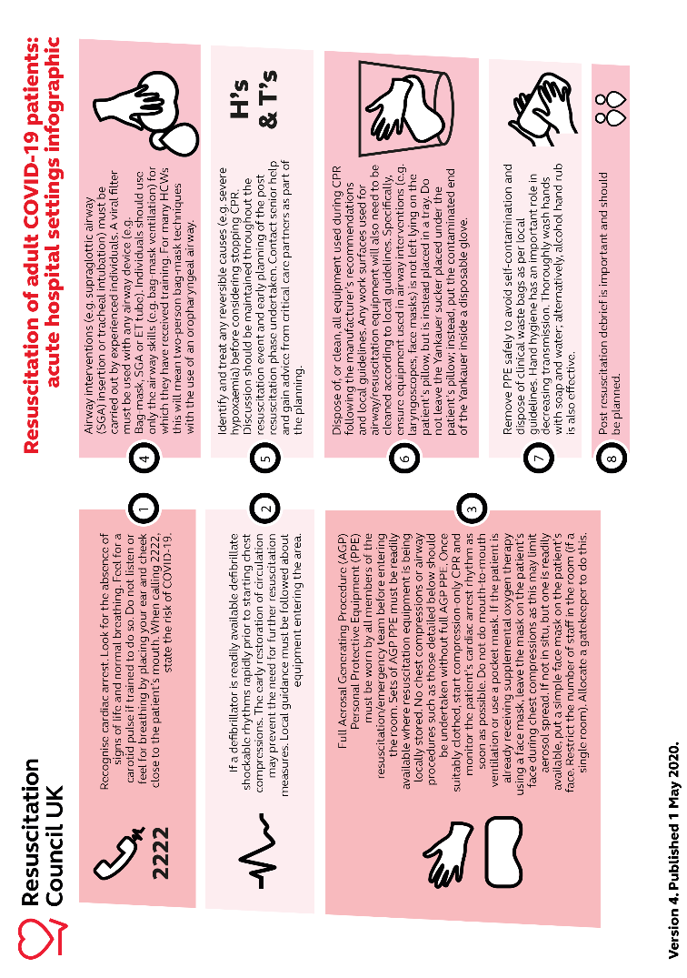

To enable this each area will ensure ttheir emergency equipment (Crash Trolley or emergency red bag) is updated in line with COVID guidance including appropriate PPE in the emergency kit for CPR: (per staff member) FFP 3 mask, gloves, visor, long sleeved fluid repellant/resistant gown with apron underneath

When to contact the GP/111/999:

999 | Chest pain that doesn’t respond to GTN protocol | Significant and persistent palpitations | Syncope/ change in consciousness level | Severe hypo/hypertension | Hypo not responding to hypo treatment/LOC | Significant SOB that isn’t resolving with rest/inhailors | Increased WOB and inadequate RR or depth of breath/noisy breathing | Significant bleeding that doesn’t stop with pressure
111 | Unable to contact GP and need guidance on what to do
GP | Medication titrations | Increased frequency of symptoms | Non-cardiac concern | Fluid retention (or HF nurse) | Concern re HR or BP home readings | Wound problems post procedure | Increasing SOB | Increasing anxiety or depression

Emergency Instructions

Calling 999:

If you phone 999 for an ambulance, please clearly state what the emergency is. eg.:

‘I have a patient with chest pain that hasn’t responded to 2 lots of GTN’
‘I have a patient with low SpO2 & increasing RR despite providing additional oxygen
‘I have a patient in cardiac arrest’

Cardiac Arrest:

If the patient has arrested, the 999 operator will have a checklist of questions that they have to work through, irrespective of the situation so please bear with them.

Have your phone on speakerphone so your hands are free for CPR/working the AED

Each time the operator asks a question “is the patient conscious?”, “is the patient breathing?” etc, clearly state – “the patient is in cardiac arrest and CPR is underway” to each question, if required. ONLY state this if it is underway
Make sure they know you are a hospital team with ILS training and are aware that you have an AED and basic emergency kit.

Hand over the patient information to the paramedics clearly and in an organized fashion.
It would be helpful to use the SBAR format in a stressful situation.

S | Situation (brief – no more than 10 seconds)  e.g. I’m a physio running a pulmonary rehab class in the community and have a patient who has chest pain that hasn’t responded to GTN.
B | Background  e.g. Mr X was discharged from hospital one week ago. He was treated for an AECOPD. On arrival to his pulmonary rehab class he was short of breath. Mr X is an ABOT user and is currently on 5LPM oxygen while at rest. He now reports worsening breathlessness after completing three exercises. Despite resting his breathlessness has increased with a RR of 41, blood pressure 199/101, heart rate 98 and SpO2 83% on 5LPM. He has a past medical history of hypertension and is a type II diabetic on metformin with a current BM of 8.3.
A | Assessment  e.g. The patient is desaturating, is tachypnea which hasn’t responded to increasing oxygen hence needs further medical investigation within a hospital setting.
R | Recommendation  e.g. We have done what we can to stabilize the patient, however have reached the ceiling of what we can do in this community setting, so the patient now needs to be taken to a hospital for further investigations/treatment as indicated.

In the event of an emergency, community locations addresses are:
Pulmonary Rehab
Harefield Community Centre
24 Priory Ave, Harefield, Uxbridge UB9 6AP

Access to car park. Class located through main entrance in main hall

More Energy Fitness Centre
College Way, Hayes, Middlesex, UB3 3BB

Access into Uxbridge College, Hayes campus. Class located in college gym

South Harrow Baptist Church Hall
270 Northolt Road, South Harrow, HA2 8EB

Access via church car park. Class located behind church

Watts Hall Christ Church

Redford Way, Belmont Road, Uxbridge, UB8 1SZ

Access to church car park. Class located through main entrance, hall at the bottom of the ramp

Yiewsley and West Drayton Community Centre
Harmondsworth road, West Drayton, UB7 9JL

Access to car park. Class located on first floor via external ramp or internal stairs

Eastcote Hockey Club
Kings College Rd, Ruislip HA4 7JZ

Access to car park. Assessments located on hockey pitch

Ruislip Baptist Church
122 Manor Way, Ruislip Manor, Ruislip HA4 8HR

Access to car park from Manor Way (one way street so access from Pembroke Road). Class in hall on first floor via side door

Cardiac Rehab
Harefield Football Cub
Preston Park, Breakspear Road North, Harefield, Middlesex, UB9 6NE

Access to car park. Astroturf is located at the back of the carpark behind the wooden fence.

St Andrews Church, Youth Centre
Malvern Avenue, Roxbourne, Harrow, HA2 9ER

Access into ‘Large Hall’ is alongside the carpark with two doors into the hall, one either side of the disabled parking spaces.

St Mark’s Church Hall
Green Tiles Lane, Denham, Bucks UB9 5HT

Access into ‘Large Hall’ is alongside the carpark with two doors into the hall, one either side of the disabled parking spaces.

Information to hand over to the paramedics:

S | Situation: (brief, no more than 10 seconds)
B | Background: PMH and HPC
A | Assessment:
R | Recommendation:

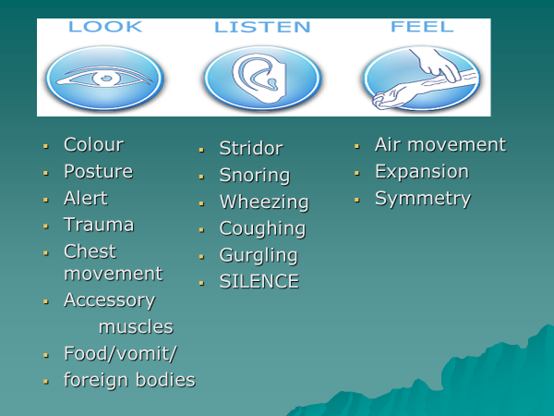

Observations to hand over to the paramedics:

Name:
D.O.B:
NHS/HN:
NOK
Callers no.

Time

RR

SpO2

LPM

HR

BP

Temp

Disability

Exposure

Glucose

