**Association of Chartered Physiotherapists in Respiratory Care Annual Report: 31 December 2015**

**Committee Membership**

|  |  |  |  |  |  |
| --- | --- | --- | --- | --- | --- |
| **ROLE** | **NAME** | **Start Date** | **End Date** | **Previous Terms** | **Status** |
| **President** | Catherine Thompson | Co-opt (stand in for SK illness for 2015) | | | |
| **Chair** | Lizzie Grillo | Jan 2015 | Jan 2018 | n/a | Full |
| **Vice Chair** | Ian Culligan | Jan 2015 | Jan 2018 | n/a | Full |
| **Treasurer**  **(incl. Member Support)** | Melanie Palmer | Jan 2015 | Jan 2018 | 1 | Full |
| **Public Relations Officer**  **(incl. Diversity)** | Laura Breach | Jan 2015 | Jan 2018 | 0 | Full |
| **Research Officer** | Frances Butler | Jan 2015 | Jan 2018 | 0 | Full |
| **LTC Champion** | Rachael Colclough | Jan 2016 | Jan 2019 | 0 | Full |
| **Critical Care Champion** | Gareth Cornell | Jan 2015 | Jan 2018 | 0 | Full |
| **Paediatric Champion** | Lynn Schofield | Jan 2015 | Jan 2018 | 0 | Full |
| **Surgery Champion** | Charlotte Pereira | Jan 2016 | Jan 2019 | 1 | Full |
| **Education Champion** | Ema Swingwood | Jan 2015 | Jan 2018 | 0 | Full |
| **Respiratory Review Editor** | Robyn Stiger | Jan 2016 | Jan 2019 | 1 | Full |
| **Journal Co-Editor** | Una Jones | Jan 2015 | Jan 2018 | 1 | Full |
| **Journal Co-Editor** | Emma Chaplin | Jan 2016 | Jan 2019 | 1 | Full |
| **Newsletter Editor** | Helen Sanger | Jan 2015 | Jan 2018 | 0 | Full |
| **Website Manager** | Matt Cox | Jan 2005 | Jan 2017 | 4 | Full |
| **On Call Project (co-opt)** | Sian Goddard | Jan 2014 | Jan 2017 | n/a | Co-Opt |
| **Secretariat** | Angela Hurlstone | n/a | n/a | n/a | Paid |

**ACPRC Secretary**

Angela Hurlstone

**ACPRC operational address**

ACPRC Secretariat Office, PO Box 4460, Slough, SL33FU

**Structure, Governance and Management**

ACPRC is a Professional Network of the Chartered Society of Physiotherapy (CSP), and a member of the CSP Cardio-respiratory Alliance. Governance and reporting requirements are set by the CSP and compliance with these requirements is essential for on-going recognition of the ACPRC as a Professional Network. CSP recognition of the ACPRC provides the organisation with many benefits including insurance cover for our property and activities, financial support through capitation fees and organisational and professional support.

The committee meets three times each year, including a two day planning meeting which is usually held in January to determine the work programme for the year. This year (2016) the ACPRC underwent a full and complete review by the current committee. As part of this review, all structure and process documents were re-written and updated by the chair and vice chair. These documents were reviewed and agreed by the committee. This annual report includes a copy of this document titled: ‘ACPRC Policy and Operations Manual’.

**Committee Structure**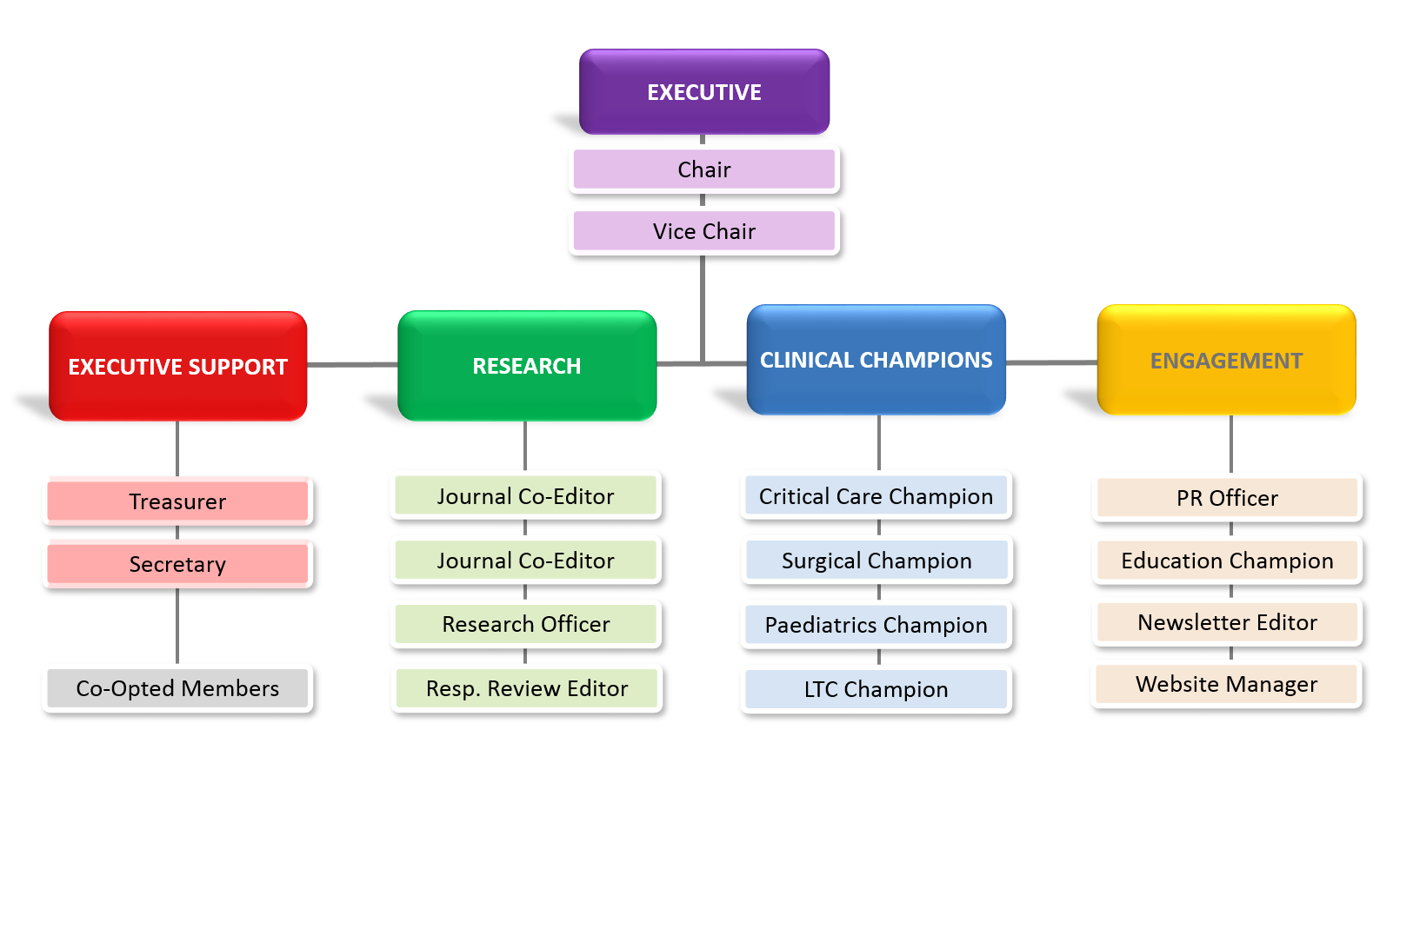

**Mission Statement**

*“Inspiring Excellence in Respiratory Care”*

**Vision**



**Sharing Knowledge and Skills**



**Facilitating Research and Best Practice**



**Leadership and Innovation**



**Connecting People**

**ACPRC membership 2015**

At 31 December 2015 we had 954 members. The majority are CSP members and the remaining are overseas members, who are members of their national professional bodies, or are non-physiotherapist members who are members of their own professional bodies.

**ACPRC Work Plan 2015 review**

Every year the ACPRC committee meets to review the progress of the previous year and set the work plan for the coming year. The review of the previous year is presented in the annual report at the on-line AGM in May 2016.

The following objectives were agreed at the ACPRC Away-day for January to December 2015

1. Deliver ACPRC conference 2015 and commence planning for 2017
2. Continue to review new website and respond to feedback from members and committee re: usability.
3. Create a marketing work plan to improve image and visibility of ACPRC
4. Co-opt a new Officer for ‘Education’ with the aim to improve and re-organise conference and study day planning.
5. To continue to progress with the On Call Project as commenced in 2014.

**Summary of 2015 activity**

1. **Deliver 2015 Conference and commence planning for 2017 conference**

The 2015 conference was successfully held at the Cheltenham Park Hotel, on 24th/25th April. The theme for the conference was ‘”Walking in the Steps of the Patient’. The Conference was a fantastic success and we had some very constructive feedback from those whom attended. Following the conference we had our first successful twitter chat on the ‘Patient Experience’.

Last year we informed you all about the potential for a joint conference with the ICCrPT in 2017. As the WCPT have altered their conferences to every two years (from every 4 years) it was decided that we would not be able to run a conference in the same year (WCPT is held in South Africa and we at ACPRC could not justify this as a venue!!). Therefore, although both parties are keen to collaborate to deliver joint education opportunities, we have begun discussions about alternative options. For details of these, please see the Aims/Objectives for 2016.

Therefore Conference 2017, will be delivered by the ACPRC alone. Planning of this conference has begun and further information will be available in September 2016

1. **Continue to review new website and respond to feedback from members and committee re: usability**

The Website and Database are in general up and running with no concerns. However there have continued to be some issues with members being unable to update their details online. However in most cases the interaction of these two platforms is enabling the ACPRC Committee and secretariat to manage subscriptions with ease. We are working hard with Arkom (website hosts) to iron out these issues. We think, in part, these issues are due to some members ID numbers transferring across to the new system (in 2013) incorrectly. If members are continuing to have problems, please contact us on [secretary@acprc.org.uk](mailto:secretary@acprc.org.uk). In response to members feedback in 2015, and also due to increased use of social media platforms, the ACPRC aims to develop the website further in 2016 into a ‘responsive website’, viewable with ease on different platforms including smart phones and tablets.

1. **Create a marketing work plan to improve image and visibility of ACPRC**

The committee has reviewed the content of the website, but there remain issues with keeping this up to date and in universal format. It has been decided in 2016 that the website manager role will aim to include this aspect from 2017. This is inline with the Committee Review as commenced in Jan 2016.

Our role on social media has exploded which has successfully enabled us to develop communication with our members and stakeholders. Our twitter following has increased by over 1000 followers in the last year. Moreover we have 810 likes on our facebook page. We have had a number of successful twitter chats as well as using these sights to have direct contact with our members. The committee have all found this very enriching and allows for real time communication with the membership.

Our profile on social media has greatly improved our outward communication and offers members and stakeholders many options for communication. The feedback from our Conference from exhibitors was very positive and gave evidence that ACPRC is seen as very professional and a key stakeholder for many of their groups. The committee have worked hard to keep our stakeholders abreast of our output and the Chair has met with the CSP, ICCrPT, BTS in 2015 to ensure they are up to date with ACPRC concerns. As well as this ACPRC are developing stronger links with the respiratory leaders and in higher education forums. As well as this we have been involved in BTS filming on the Role of the Physiotherapist.

1. **Co-opt a new Officer for ‘Education’ with the aim to improve and re-organise conference and study day planning.**

Our new education champion helped to plan and re-structure our education programme for 2016 (please see operations and policy manual). A new format and process for Courses was commenced and concluded at the end of 2015 during the away day. Such focus has galvanized this aspect of the ACPRC Role for members and we fully believe a focused Education Champion will ensure this aspect of the ACPRC will continue to have momentum. So far 3 courses have been completed in 2016 as a consequence of this focus. Please see our 2016 plan for more details.

1. **To continue to progress with the On-Call Project** *(action points 2015 in italic)*

*Position Statements/Toolkit/iCSP concerns*

These were all completed and presented at our Conference last year. Information will soon be available on the website.

*Resources for members (Including self evaluation questionnaire and guidance documents)*

These have been commenced in earnest including near completion of the self-evaluation questionnaire. This will be available in the second half of 2016. Other resource for members, including on-call training was not completed in 2015 but carried over to this years timeline as we have gained support from an MSc student to help complete a project to evaluate training needs which will be completed in September 2016 and will hopefully improve our understanding of course content.

The guidance documents will become an invaluable resource and these will be completed in 2016.

*On-call Training (including online resources)*

The training packages are being developed with a hopeful Paediatrics course being completed in Sept/Oct 2016. As well as this Mandy Thomas has offered to host a SIM Training Masterclass with UCL Partners, this should help us develop members experience in using SIM for on-call scenarios. With regards to Adult training, there is communication with the respiratory leaders to develop the adult training collaboratively with our partners. ACPRC aim to develop these courses and host them initially with the future aim of the content being available to members in their resource packs.

*Develop communication with Managers / Stewards and Health and Safety reps for this work plan*

No progress as yet, however ACPRC plan on disseminating information at the EWCPT in Liverpool in November 2016, as this seemed an excellent forum to utilise. Therefore ACPRC will use this conference as a platform to share the on-call work so far.

The on-call project is one of our larger work streams and will need more than 12 months to complete. Some great progress has been made and we hope to use 2016 and the lead up to our conference in 2017 to complete this work.

**Additional activities completed 2015**

Ongoing involvement in NICE Guideline consultation

Involvement in BTS Bronchiectasis Guideline review

Support and Guidance to the CSP Inspire Project

Support and involvement in the PhysioWorks COPD project (CSP)

**Summary**

Over the last year the ACPRC have become acutely aware of the changing needs of Professional Networks. This includes their role in supporting physiotherapists with their professional profile, educational needs and providing support in the developing NHS. As a committee we felt there may have been a potential mismatch for some of our members with how the ACPRC is achieving this role. Moreover the visibility of the ACPRC in delivering on this agenda has at times not been as clear as we would have liked. As a committee we have become concerned about the optimal ways of driving and delivering on our work plans. More than this, we are keener than ever to engage with our membership through the development of our profile within social media and through our educational priorities.

Last year we faced a number of challenges with a large change in committee members, due to both illness and other factors. This has meant we have enjoyed welcoming a number of new and enthusiastic members. We are a committee which includes B6's to B8a's, across both hospital based roles, research and education. We are a young committee but an enthusiastic one who is keen to deliver a high quality, well respected and engaged professional network group.

Over the last year we have successfully developed many relationships with stakeholders including the ICCrPT, BTS, ICS, NICE and the CSP to name a few. This has demonstrated how highly regarded our network is, as well as emphasising the importance of the ACPRC being a voice to all physiotherapists within the cardiorespiratory field. Moreover the visibility of such roles to members and stakeholders has never been more important.

Therefore Ian (Vice Chair) and myself with the support of the committee felt that our annual Away Day in November 2015 (where we review our upcoming work plan) should be used as an opportunity to review ALL aspects of the ACPRC, for the benefit of all. The aim of such a review was to ask the questions; How are we doing? What can we do better? What scaffolding does the ACPRC need in order to deliver the vision that our members would get the most benefit from?

This review was completed in December 2015 and approached this challenge by having a series of workshops and strategy exercises to engage an open discussion of the role of our group. Moreover we also looked at all our structural processes with the aim to review how effectively we work as a team. We were keen to understand any mismatch between our intentions of the committee and the expectations of the wider membership, including our stakeholders. Our overall aim was to consider how to develop further as a committee and to expand the benefits to members of being part of this growing network.

We had a successful few days, and followed this up with our annual committee meeting where our work plans for both this year and over the next 5 years were discussed. Moreover we have completely re-written our process and structure details of which are available for you to review. The aim of our new Operating Procedures are to help the committee work more efficiently and transparently.

This review has highlighted the challenges of a voluntary and often changing committee, and aims to provide some structure and permanence to our processes. We are continuing to use 2016 to establish such processes and hope this will enable our committee to develop in strength, visible to both our members and stakeholders.